AI ASSISTED CODING
ASSIGNMENT-10.2
NAME: D. SIDDHARTHA
Roll No: 2503A51L04
BATCH: 24BTCAICSB19

Lab Objectives:
- To understand the importance of code readability, maintainability, and quality.
- To explore how AI-assisted coding tools can review code and suggest improvements.
- To practice identifying code smells, redundant code, and poor naming conventions.
- To apply AI tools for refactoring and improving readability.
- To critically evaluate AI feedback and integrate it into real projects.

Lab Outcomes (LOs):
After completing this lab, students will be able to:
- Use AI-assisted tools (e.g., GitHub Copilot, Cursor AI) to review Python code.
- Identify and correct syntax issues, code smells, and inefficient logic.
- Improve readability by applying consistent formatting, naming, and comments.
- Refactor code with AI suggestions while ensuring functionality is preserved.
- Apply best practices for writing clean, maintainable, and professional code.

Task Description#1 AI-Assisted Code Review (Basic Errors)
•Write python program as shown below.
•Use an AI assistant to review and suggest corrections.
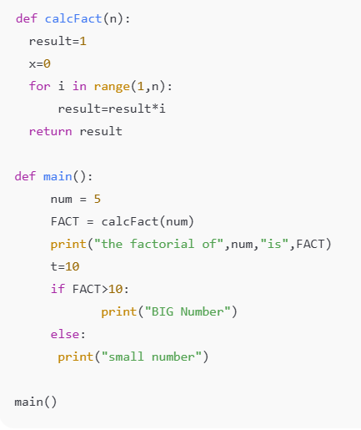
Program:
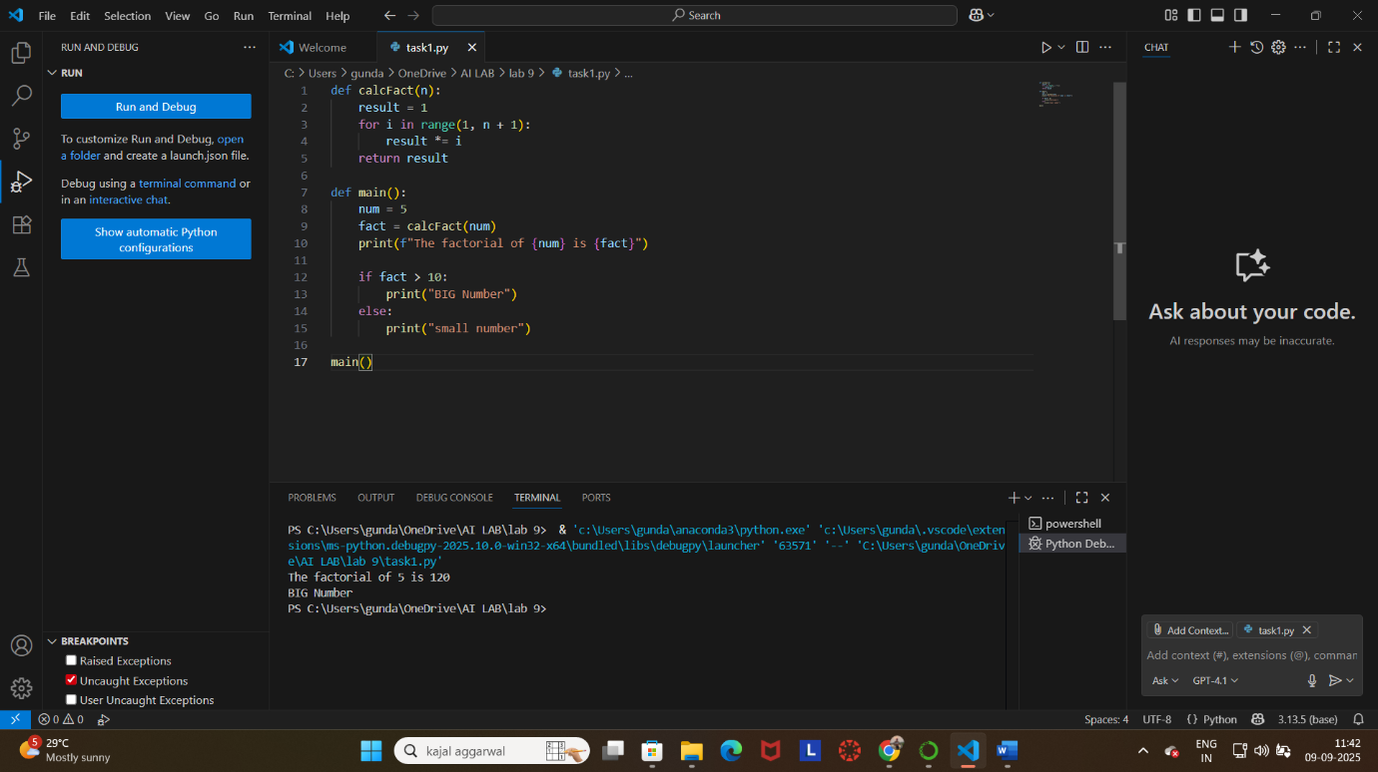
Output:
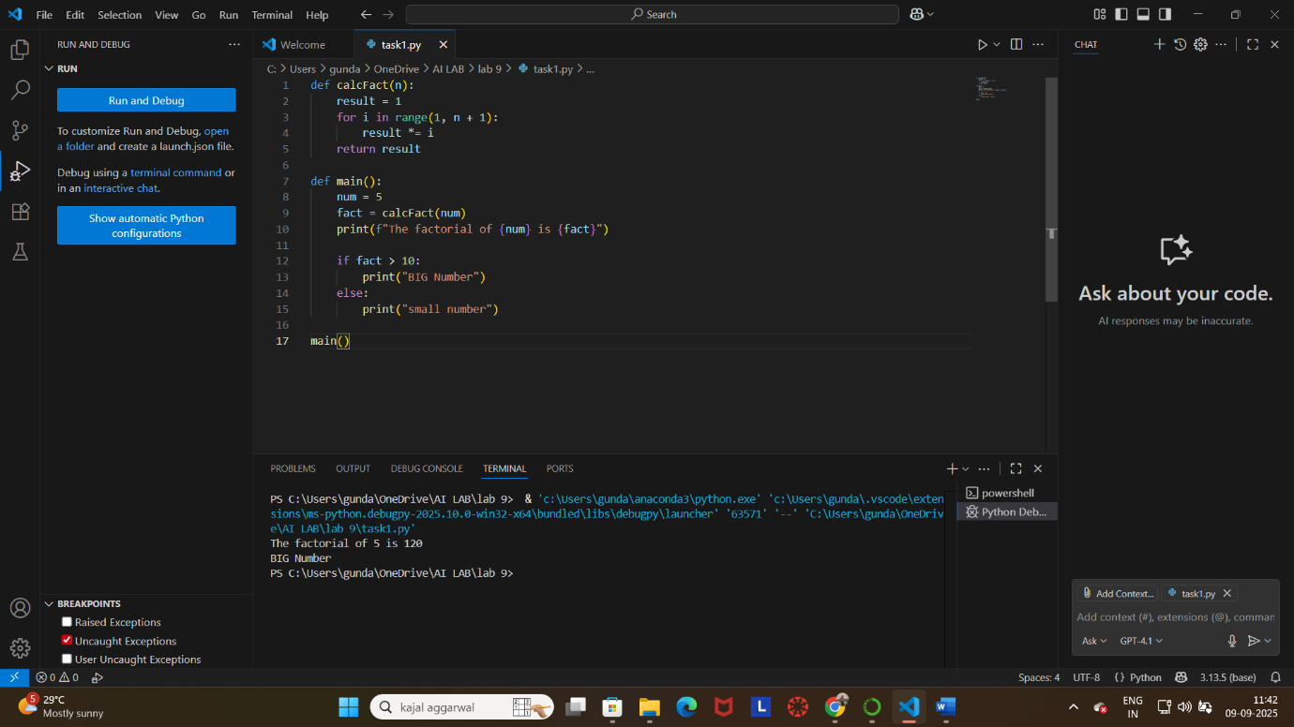

Task Description#2 Automatic Inline Comments
- Write the Python code for Fibonacci as shown below and execute.
- Ask AI to improve variable names, add comments, and apply PEP8 formatting (cleaned up).
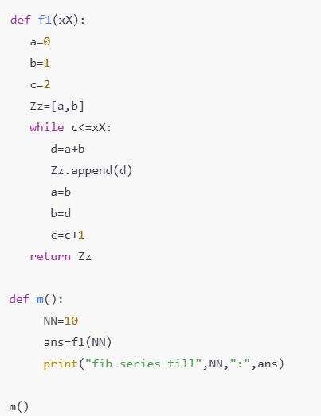
- Students evaluate which suggestions improve readability most one.

Program:
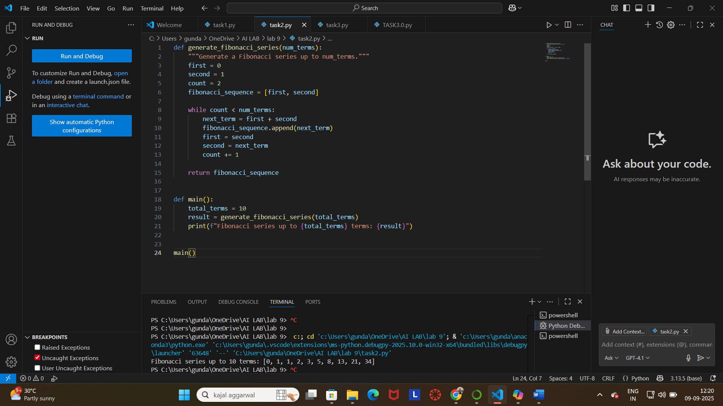
Output:


Task Description#3
•Write a Python script with 3–4 functions (e.g., calculator: add, subtract, multiply, divide).
•Incorporate manual docstring in code with NumPy Style
•Use AI assistance to generate a module-level docstring + individual function docstrings.
•Compare the AI-generated docstring with your manually written one.

Manual Code:

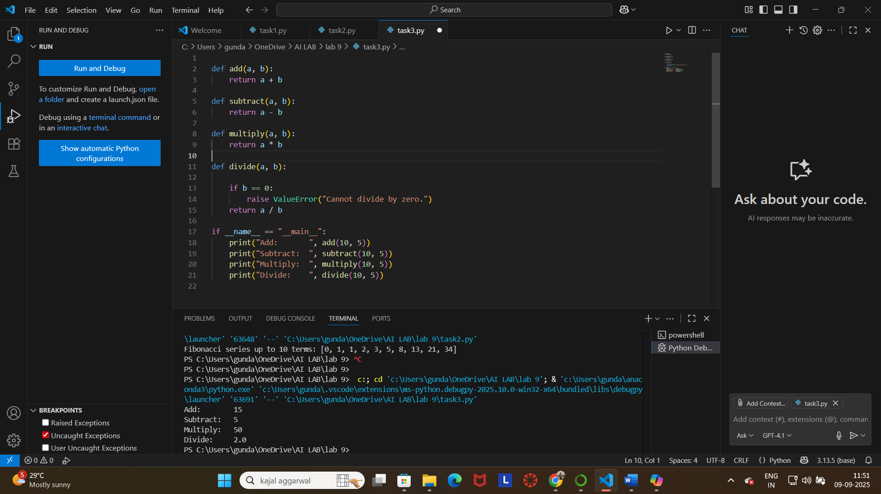

Output:


Using AI assistance to generate a module-level docstring + individual function docstrings:
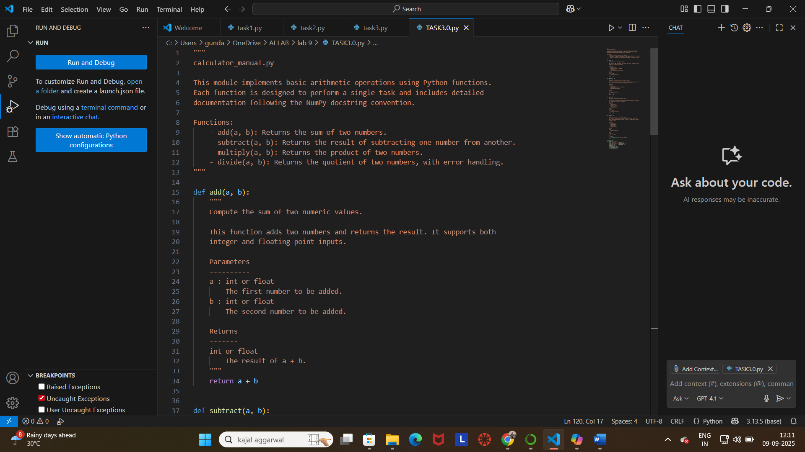

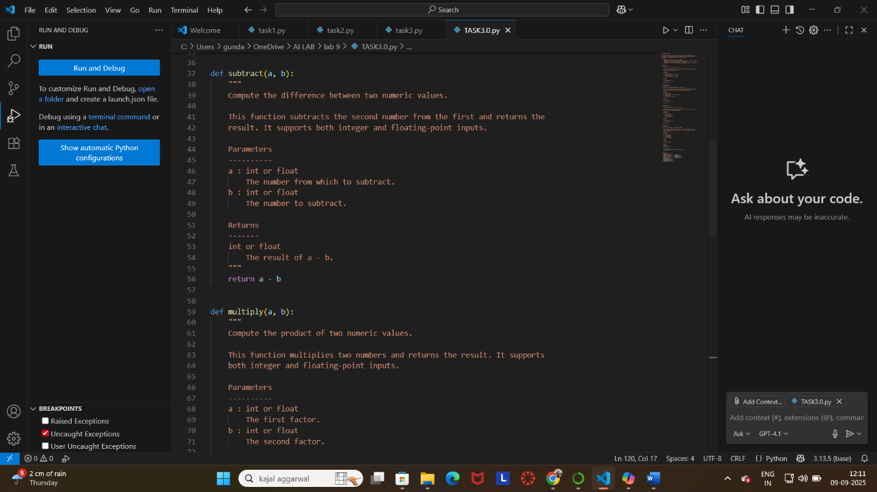
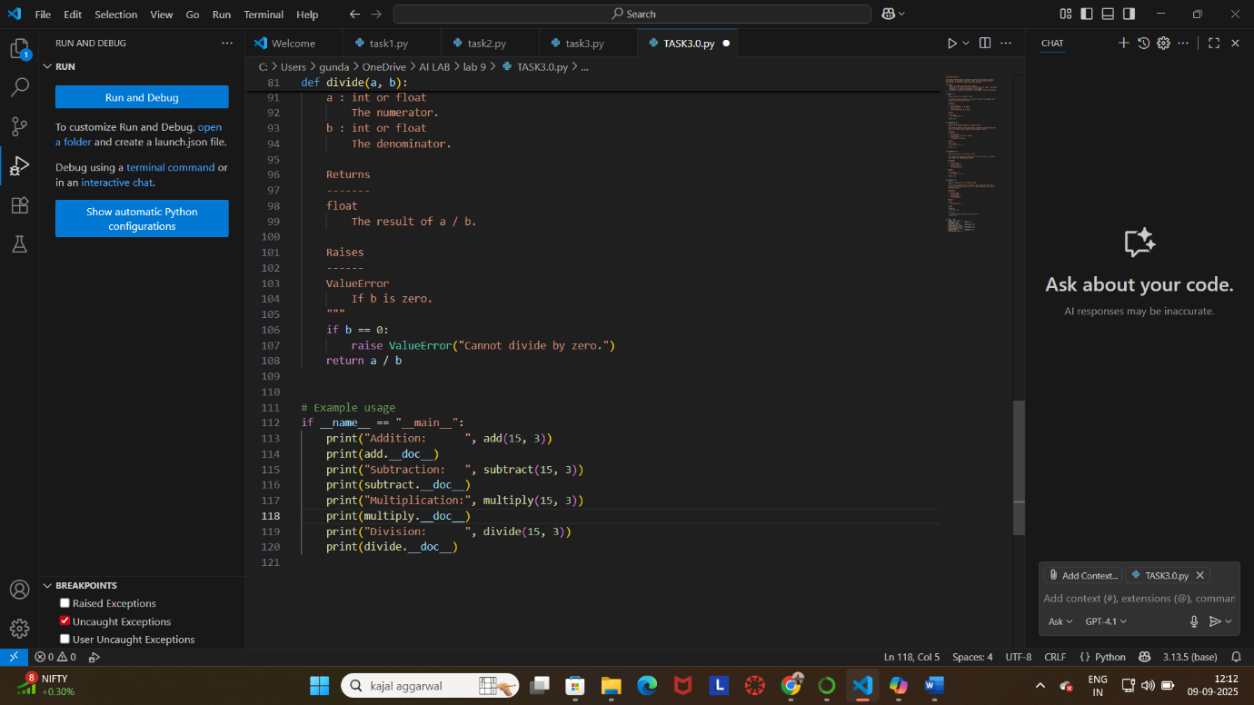

Output:

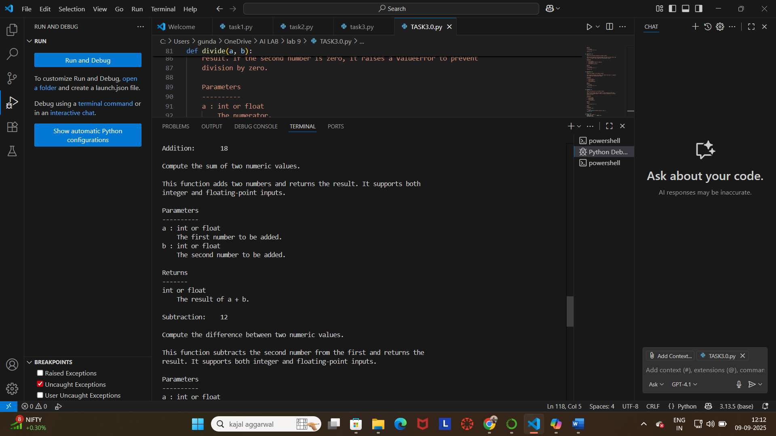
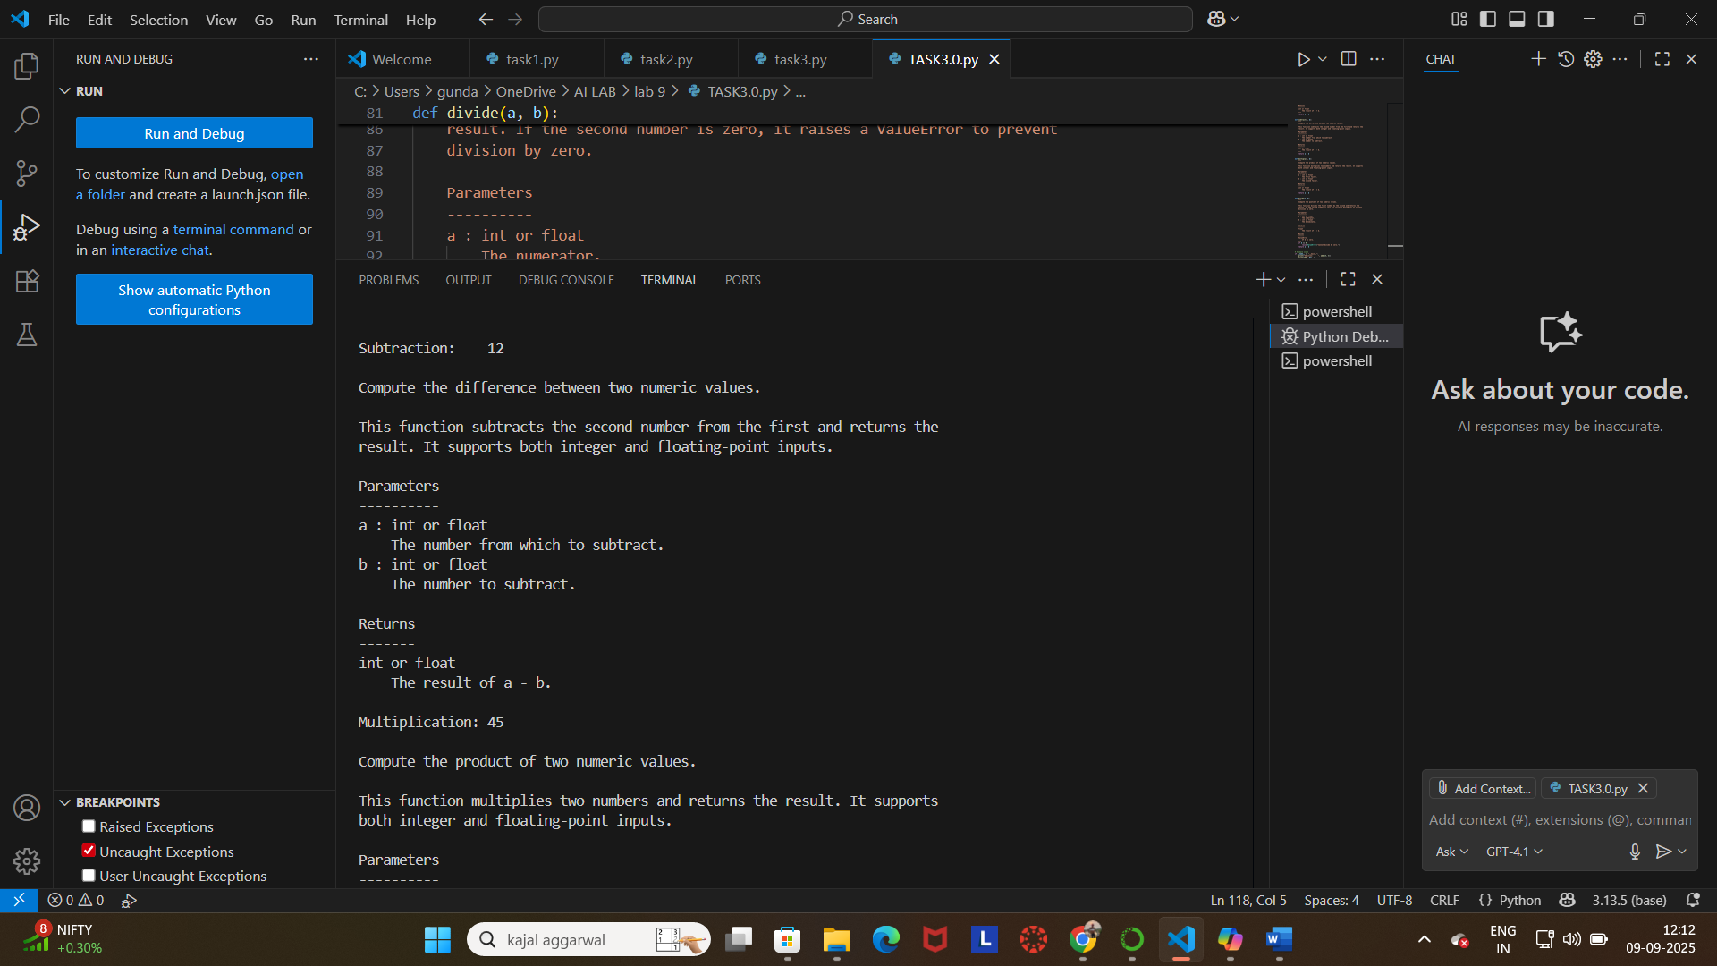

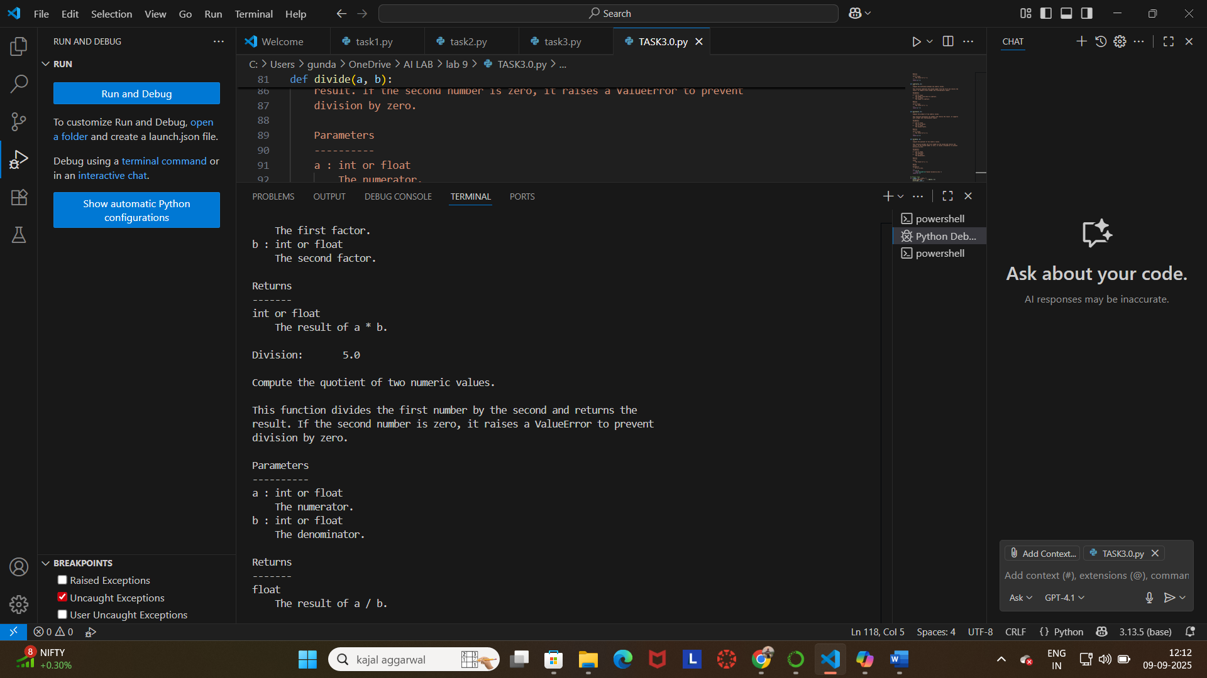

Docstring Comparison: Manual vs AI-Generated
Aspect | Manual Docstring | AI-Generated Docstring
Length | Short and concise | More detailed and structured
Style | Informal and straightforward | Formal and follows NumPy style strictly
Purpose | Briefly states what the module does | Clearly states purpose, includes context (‘demonstrate the use of docstrings in N
Metadata | None | Includes author and date
Function Coverage | General description of all four functions | Mentions all functions with a clear description
Clarity | Clear, but less descriptive | Very clear, structured, and beginner-friendly
Extra Sections | None | Can include Examples, Raises, and Notes sections (more extensible
Professionalism | Basic, suitable for quick documentation | Professional, suitable for production-level documentation

